Tables and Figures

Table 1. Summary Statistics
 | Freq. | Percent
Panel A. Gender identity
Cisgender man | 2,675 | 35.56
Cisgender woman | 4,289 | 57.02
Transgender man | 59 | 0.78
Transgender woman | 20 | 0.27
Nonbinary | 267 | 3.55
Gender diverse/questioning | 71 | 0.94
Prefer not to say | 141 | 1.87
Total reported gender identity | 7,522 | 100.00
Panel B. Sexual orientation
Straight/heterosexual | 5,190 | 69.38
Gay or lesbian | 330 | 4.41
Bisexual/pansexual/omnisexual | 1,139 | 15.23
Asexual/aromantic/demisexual | 182 | 2.43
Other/queer/questioning | 131 | 1.75
Prefer not to say | 509 | 6.80
Total reported sexual orientation | 7,481 | 100.00
Panel C. Race/ethnicity
American Indian/Alaskan Native | 163 | 2.14
Black/African American | 532 | 6.99
Hispanic/Latinx | 3,793 | 49.82
Pacific Islander | 64 | 0.84
Filipino | 235 | 3.09
Asian | 1,146 | 15.05
Other | 182 | 2.39
White/Non-Hispanic | 1,498 | 19.68
Total reported race/ethnicity | 7,613 | 100.00
Panel D. Highest level of education among parents
Did not complete high school | 1,373 | 18.11
High school diploma | 1,578 | 20.81
Some college, no college degree | 975 | 12.86
Associate degree | 452 | 5.96
Bachelor's degree | 1,363 | 17.97
Graduate/Professional degree | 1,455 | 19.19
Don’t know | 387 | 5.10
Total reported parental education | 7,583 | 100.00
Note. Our sample only includes college-going high school seniors. Of the total sample (n = 9,230), 1,708 respondents did not report gender identity; 1,749 did not report sexual orientation; 1,617 did not report race/ethnicity; and 1,647 did not report level of parental education.

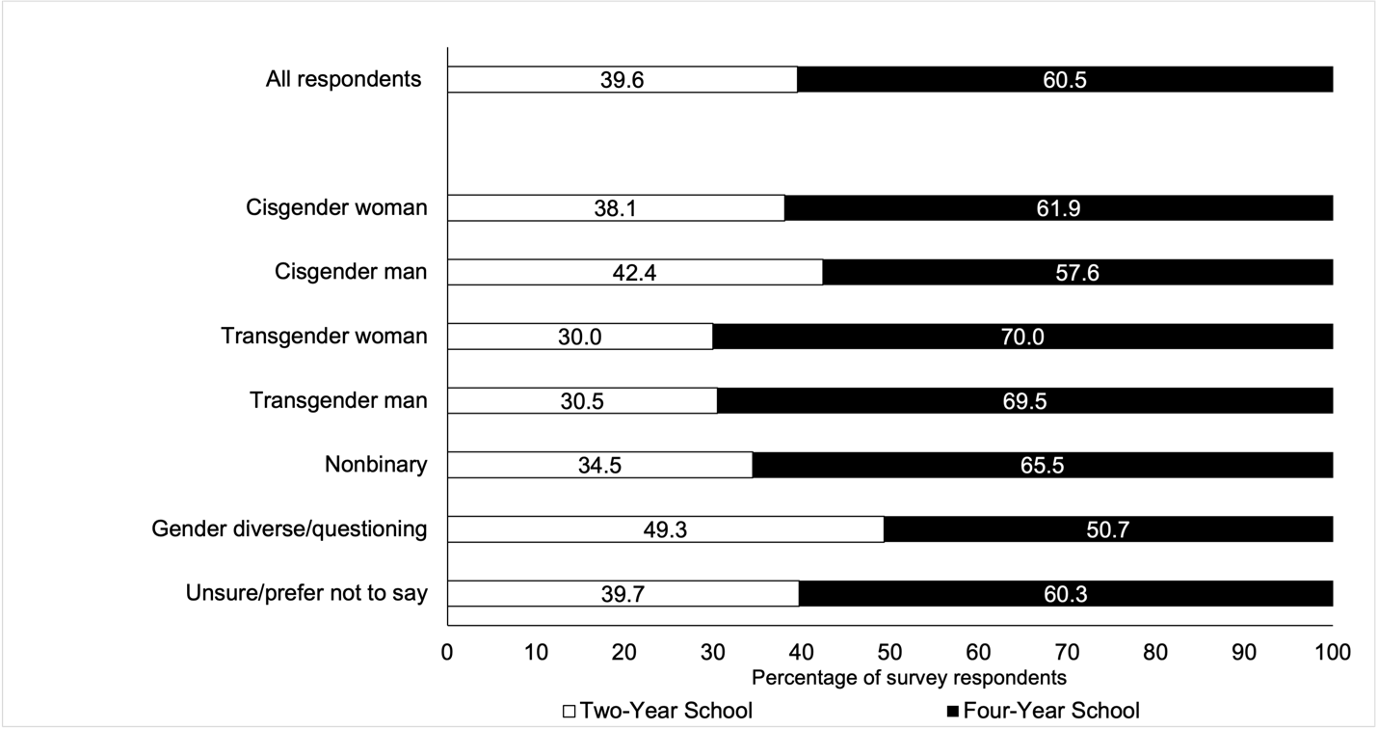
Figure 1. Plans for college enrollment
Note. Rates depicted in the figure represent 7,522 survey respondents who indicated plans to attend college. Of the full survey sample of high school seniors (n = 10,221), 9,230 respondents indicated that they planned to go to college, 170 said they did not plan to attend college, 294 expressed that they were unsure, and 527 did not respond to the question.

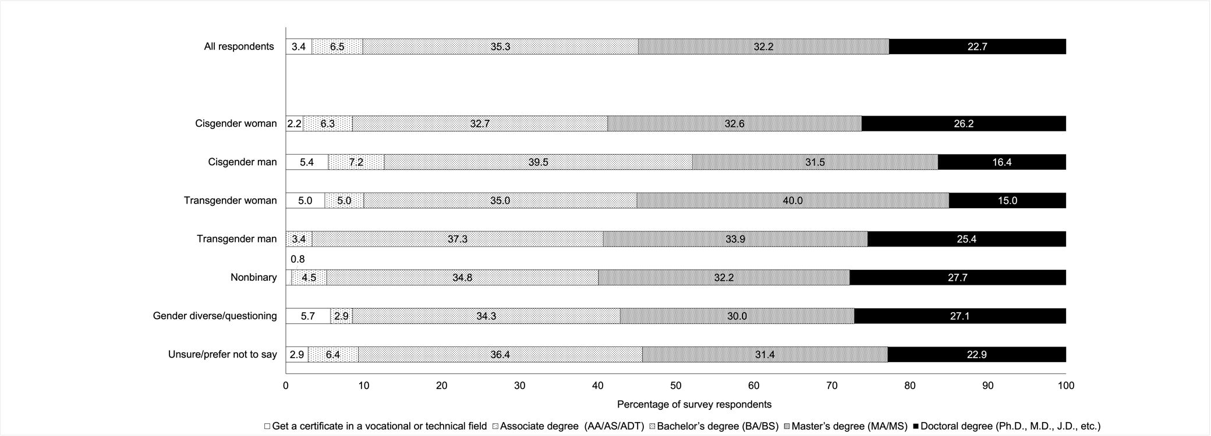
Figure 2. Plans for degree completion
Note. Rates depicted in the figure represent 7,497 survey respondents who indicated plans for degree completion.

Table 2. General High School Experience by Gender Identity
 | Freq. | General high school experience index
Cisgender man | 2,659 | 4.271
Cisgender woman | 4,269 | 3.787
Transgender man | 59 | 2.424
Transgender woman | 20 | 2.55
Nonbinary | 267 | 2.318
Gender diverse/questioning | 71 | 1.113
Prefer not to say | 138 | 2.232
Total | 7,483 | 3.839
Note. The general high school experience index only applies to students who reported non-missing values for all six high school experience items and ranges from -12 to 12 (negative values indicate a negative experience, positive values indicate a positive experience, and zero indicates a neutral experience).

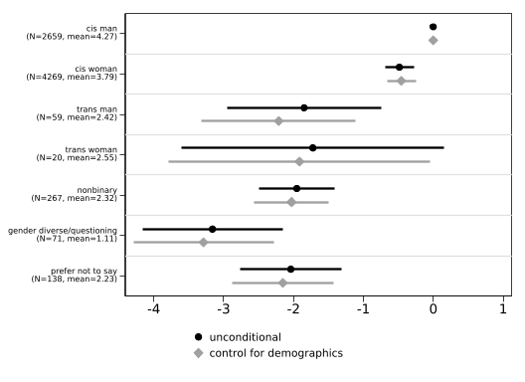
Figure 3. Regression of Overall High School Experience on Gender Identity Categories
Note. For the unconditional model, n = 7,483. For the model controlling for demographics (race/ethnicity and parental level of education), n = 7,464. The lines indicate 95 percent confidence intervals while the sample frequency and mean index of each gender identity are reported in parentheses.

Table 3. College Concern Items and Results from Principal Component Analysis (PCA)
 | N | Mean
Items:
How worried are you about affording tuition fees | 7,957 | 1.827
How worried are you about living expenses | 7,956 | 1.676
How worried are you about performing well academically | 7,958 | 1.502
How worried are you about balancing work obligations | 7,943 | 1.557
How worried are you about balancing family obligations | 7,941 | 1.055
How worried are you about finding community | 7,934 | 1.316
How worried are you about living away from home | 7,948 | .908
How worried are you about having adequate support for emotional and mental health needs | 7,944 | 1.127
How worried are you about discrimination based on gender | 7,886 | .436
How worried are you about discrimination based on sexual orientation | 7,876 | .333
How worried are you about discrimination based on race | 7,895 | .514
How worried are you about discrimination based on religion | 7,891 | .232
PCA Constructs:
General worries (32.03%) | 7,706 | 3.776
Worries about discrimination (13.79%) | 7,706 | -1.219
Worries about financial burdens (10.26%) | 7,706 | .634
Note. The first twelve rows are items related to college worries included in the survey. Each item ranges from 0 to 3, where 0 represents not worried at all and 3 represents very worried. The last three rows indicate the three constructs: (1) general worries ranges from 0 to 10.23; (2) worries about discrimination ranges from -3.83 to 5.12; and (3) worries about financial burdens ranges from -3.64 to 3.65. Constructs are only created for high school students that reported non-missing values for all twelve items regarding college worries. The PCA proportion explained is reported in parentheses after each construct.

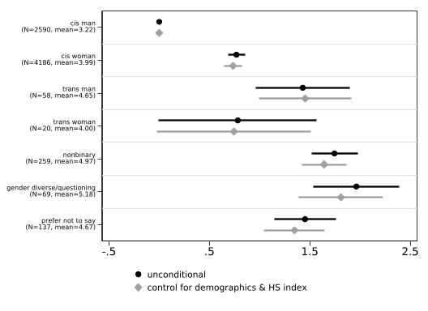
Figure 4. Regression of General College Worries on Gender Identity Categories

Note. We estimate regression models with gender indicators for an unconditional model (n = 7,319) and include race/ethnicity indicators, parental education indicators, and a constructed high school experience index as covariates for the specification with control variables (n = 7,276). The lines indicate 95 percent confidence intervals while the sample frequency and mean for each gender identity are reported in parentheses.

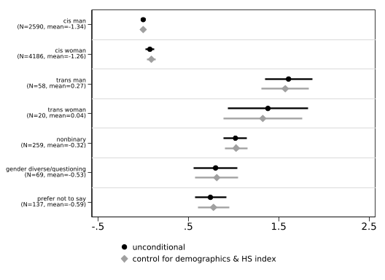
Figure 5. Regression of Worries about Discrimination on Gender Identity Categories
Note. We estimate regression models with gender indicators for an unconditional model (n = 7,319) and include race/ethnicity indicators, parental education indicators, and a constructed high school experience index as covariates for the specification with control variables (n = 7,276). The lines indicate 95 percent confidence intervals while the sample frequency and mean for each gender identity are reported in parentheses.

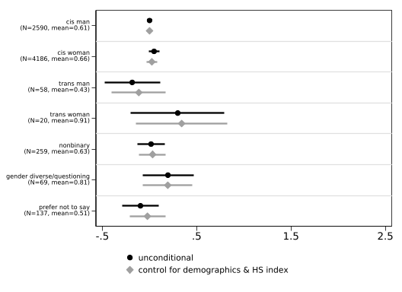
Figure 6. Regression of Worries about Financial Burdens on Gender Identity Categories
Note. We estimate regression models with gender indicators for an unconditional model (n = 7,319) and include race/ethnicity indicators, parental education indicators, and a constructed high school experience index as covariates for the specification with control variables (n = 7,276). The lines indicate 95 percent confidence intervals while the sample frequency and mean for each gender identity are reported in parentheses.

